POSITION SUMMARY

Job Title: | Trade Policy Advisor
Division: | Trade
Responsible To: | CEO
Responsible For: | N/A
Job Purpose: | Lead BTIB in providing effective and efficient advice in the identification, promotion and development of trade opportunities that provides the impetus for sustainable and long term economic growth and benefit for the Cook Islands and by doing so give effect to the Economic Strategy, NSDP, Regional projects and organization strategies.
Job Classification: | Function: Business Services
Date updated: | Jobwise Code ()

AGENCY Vision
“Economic growth and prosperity for the people of the Cook Islands”

OrganisationAL STAFFING STRUCTURE

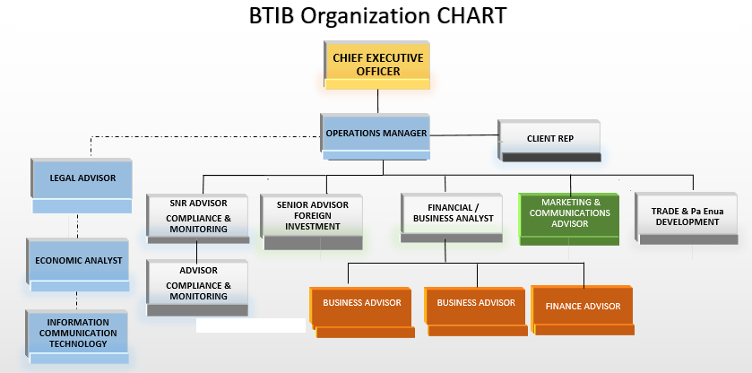

KEY RESULT AREAS (KRA’s)/Outputs
KRAs for this position (maximum of 6)  1. Trade Opportunities  2. Database integrity  3. Foreign Direct Investment Support  4. Management & Teamwork | Key Performance Indicators (use SMART principles)
KRA1: Trade Opportunities  - Primary lead in the development of a Trade framework that builds long-term value for the Cook Islands.  - Develop, review and updating of all current and future Trade initiatives.  - Develop and maintain business relationships and ensure that these are managed so that they leverage off advantages and opportunities afforded by these relationships  - Provide professional Trade advice that is timely, clear, qualified, impartial business advice on a programme of scheduled work  - Supporting, coordinating and meeting the capacity/training/up-skilling needs of locals into Trade ventures to lift their knowledge and business skills  - Drive the identification of networking and strategic partnering arrangements that identify opportunities for building local business capacity  - Keep abreast of research and policy development on Trade initiatives.  - Regularly research, collect and analyse Trade business data and report the findings to enable a focused strategic Trade alignment.  - Monitor and report on the implementation of International and Regional Trade initiatives.  - Advise and Guide CEO and Board on Pacer Plus Trade Agreement obligations and what that means for the Foreign Investment environment of the Cook Islands. | - An effective Trade Strategy is developed and implemented.  - Process developed that captures relevant data for analyses and reporting  - All MOUs, partnering arrangements and formal relationship agreements are signed on time and monitored effectively  - Project plan with timelines and milestones implemented for review and update of Trade manual  - A Trade policy that draws together producers, sellers and consumers is developed.  - Legal Advice and explanations are provided timely and articulated clearly to the CEO and Board of any ramifications in regards to Pacer Plus agreement obligations upon the Country with options to respond.
KRA2: Database Integrity  - Manage a fit for purpose user friendly Trade database.  . | - Technological issues encountered with the database are reported immediately to the divisional head for review and remediation  - Statistical models for research that enables the identification of solutions based activities are designed, developed and implemented  - The interpretation of statistical analysis of International Organization analysis, survey material to gauge which informs the business decision making of the Board.  - All captured data provide the means to identify issues and options for mitigating divisional and organisational risk.
KRA3: Foreign Direct Investment Support  - The receiving, advising and processing of Foreign Enterprise Registration Applications to the Board from time to time.  - The filing of and maintaining of said applications approved by the Board according to filing system. | - All Foreign Enterprise applications are processed efficiently and effectively for the Board.  - Database accurately maintained and up to date.
KRA4: Management & Teamwork  - Develops and implements specialised or targeted programmes and projects in response to changing or new organisational, business or government initiatives and priorities.  - Develop relationships with key stakeholders, public sector, donor agencies, financial and training institutes that ensures national and ministerial priorities are being met.  - Identify opportunities for improving the effectiveness of the division’s responsibilities.  - Sets annual targets for the division and prepares monthly reports as required by the CEO and Board.  - Support the development of annual divisional budget outputs/resources and work plans aligned to National Sustainable Development Plan (NSDP), and Trade development strategies as part of the annual Ministry Business Plan and reporting process.  - Engage effectively with colleagues and staff.  - Create a team environment that fosters and develops effective working relationships and high performance.  - Demonstrate self-management and continuous improvement in own performance and personal development.  - Compliance with Code of Conduct and all internal Government of the Cook Island and Public Services Commission policies.  - Positively contributes to improvement in output delivery by the team, efficiency of processes, procedures and behaviours.  - Willingly assist the CEO and Operations Manager & Operations Manager and other team members to learn new skills and share knowledge. | a) Sufficient resources are allocated to support the Trade policies and strategies in BTIB;  b) Staff at BTIB are trained to help support the Trade initiatives agreed to by government;  c) support the work of other agencies in achieving a given common goal;  d) Review and update data and information within BTIB and with partners to ensure accurate trade portal at all times;  e) share information with BTIB staff to assist with capacity building and strengthen support with the Trade Policies;  f) Review and improve the standard and quality of required work delivery;  g) Negotiate with other agencies priority areas in the delivery of work outputs;  h) Provide timely and meaningful information on Trade activities that impinge on Trade Policies and strategies.  i) Identify opportunities that would add value to the Cook Islands Trade products or services.

Work Complexity
Indicate most challenging problem solving duties typically undertaken (3-4 examples):
1 | Facilitating stakeholder meetings who have conflicting priorities and managing their competing priorities.  Providing clear and accurate legal advice to the Board.  Interpreting Trade Agreements into the Cook islands context.
2 | Alignment of divisional strategies to Board, Ministerial and National priorities – Developing strategies based on a consideration and allocation of conflicting staff, work, resource and timing priorities.
3 | Trade research, collating and analysis capacity – Developing a programme of research from published papers from various well-known and obscure sources for data analysis and putting together recommendations for action.
4 | Working with various organizations.

Authority
Authority levels expressed in terms of routine expenditure, granting loans, and recruiting and dismissing staff. (Explain the authority if any)

Financial | No
Staff | No
Contractual | No

Functional Relationships
The requirement for human relations skills in dealing with other personnel and external contacts. (List the external and internal types of functional relationships)

Internal | Nature of Contact | External | Nature of Contact
Head of BTIB | Medium - Reporting, advisory | Public | Minimal - Advisory
Divisional Heads | Medium – Supporting and reporting, advisory | Other Government Ministries Agencies and Stakeholders | Medium – Reporting, Advisory,
Specialised information | Medium – Analysing and integrate into policies and strategies or advice to Government | International Organizations | Medium to Promoting with an element of negotiation

QualificationS (or equivalent level of learning)
Level of education required to perform the functions of the position. This combines formal and informal levels of training and education.
Essential: (least qualification to be competent) | Desirable: (other qualifications for job)
BCom, BSocSci, BBS, BA | A relevant undergraduate degree in social sciences, business administration, policy management or Trade Law

Experience
The length of practical experience and nature of specialist, operational, business support or managerial familiarity required. This experience is in addition to formal education.
Essential: (least number of years to be competent) | Desirable: (target number of years you are looking for)
- A minimum of seven (7) years relevant work experience at an Advisory level.  - Experience in policy formulation and development.  - Experience in managing an office environment.  - High level of accuracy.  - Highly developed written and oral communication skills in both English with some Cook Islands Maori.  - Proven ability producing reports. | - 10 years or more at an advisory position with at least 3 years at a senior position with proven demonstrable experience in the essential competencies required for the role.  - Knowledge and understanding of the institutional, legal and policy frameworks at national and local level.  - Knowledge and understanding of Trade Agreements in particular Pacer Plus.

Key Skills /AttributeS/JOB Specific Competencies

Level of ability required for the job
Expert | - Written and oral communication skills in English  - Trade Agreements  - Provision of Trade advice.  - Promotion  - Negotiation
Advanced | - Proficient in the use of the Microsoft Office suite software  - Legal compliance process  - In-depth knowledge of institutional, legal and Government policy frameworks
Working | - Planning, budgeting, reporting and project cycles  - Effective communication skills  - Annual reporting.  - Customer services  - Understanding of local business issues  - Networking effectively  - Working knowledge of Cook Islands Maori
Awareness | - Some knowledge of Government frameworks  - NGO/CSO/Local Business engagement at Government level

CHANGE to JOB description
Changes to the Job description may be made from time to time in response to the changing nature of the Agency work environment - including technological or statutory changes.

Approved:

HoM/Manager Date

Employee Date

