POSITION SUMMARY

Job Title: | Trade and Pa Enua Development Coordinator
Division: | Trade
Responsible To: | Operations Manager
Responsible For: | National trade co-ordination
Job Purpose: | To facilitate and coordinate with stakeholders the National Trade plans and projects – export within country and across borders and support management initiatives.
Job Classification: | To be determined by evaluation committee (proposed Band G)
Date updated: | New position

AGENCY Vision
“Economic growth and prosperity for the people of the Cook Islands”

OrganisationAL STAFFING STRUCTURE

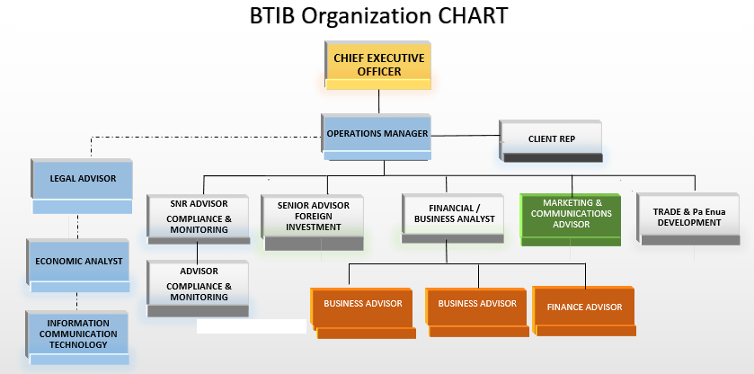

KEY RESULT AREAS (KRA’s)/Outputs
KRAs for this position (maximum of 6)  - Facilitate and Coordinate Trade activities  - Database management  - Trade Portal maintenance  - Additional Services | Key Performance Indicators (use SMART principles)
KRA 1: Facilitate and Coordinate Trade activities | Job Holder is successful when:
- Support the further development of National Trade activities from the outer islands to Rarotonga.  - Provide support in the implementation of the National and International Trade strategies.  - Provide technical support in the development and implementation of pragmatic National Trade work plans for specific programmes, in line with national and island priorities.  - Support cross-cutting research and advocacy work around Trade.  - Coordinate capacity building initiatives on Trade for interested private businesses.  - Establish and implement the “go local” brand for Cook Islands made products and services.  - Support an agenda that promotes National awareness raising in all Cook Island Government department programmes, policies and plans.  - Provide support on appropriate Trade sensitive indicators that align with the Ministry’s Business Plan and National priorities of the National Sustainable Development Plan (NSDP).  - Support the research, collect and analyse Trade data and report the findings to the Trade Policy Advisor. | - A clear and simple trade strategy is endorsed and effectively implemented for all parties;  - Database is regularly updated and used to inform policies and strategies;  - MOUs are relevant and effective in achieving quality results for partners involved;  - Project plan with timelines and milestones implemented for review and update of Trade manual  - Cook Islands products are clearly labelled on Cook islands and overseas markets.
KRA 3: Database Management | Job Holder is successful when:
- Coordinate the management of the Trade Database to ensure it is recent and relevant for the purposes of feeding Trade policy and strategy analysis and development. | - Database is regularly updated to make trade information relevant at all times.
KRA 4: Trade Portal Maintenance | Job Holder is successful when:
- Provide support to Trade portal contact in the maintenance of the Trade Information Portal.  - Support the coordination of information gathering between stakeholders for the purposes of the Trade Information Portal. | - Information on the Trade Portal is relevant and accurate
KRA 5: Management & Teamwork | Job Holder is successful when:
- Support the development of annual divisional budget outputs/resources and work plans aligned to National Sustainable Development Plan (NSDP), and Trade development strategies as part of the annual Ministry Business Plan and reporting process.  - Engage effectively with colleagues and staff.  - Create a team environment that fosters and develops effective working relationships and high performance.  - Develop and maintain positive working relations with a wide network of partners, including Government, development partners, media, NGOs and regional partners.  - Develop and maintain sustained partnerships and alliances with civil society organisations at national, regional and global level.  - Demonstrate self-management and continuous improvement in own performance and personal development.  - Compliance with Code of Conduct and all internal Government of the Cook Island and Public Services Commission policies.  - Positively contributes to improvement in output delivery by the team, efficiency of processes, procedures and behaviours.  - Assist the Senior Trade Policy Advisor & Operations Manager and other team members to learn new skills and share knowledge. | a) Sufficient resources are allocated to support the Trade policies and strategies in BTIB;  b) Staff at BTIB are trained to help support the Trade initiatives agreed to by government;  c) support the work of other agencies in achieving a given common goal;  d) Review and update data and information within BTIB and with partners to ensure accurate trade portal at all times;  e) share information with BTIB staff to assist with capacity building and strengthen support with the Trade Portal.

Work Complexity
Indicate most challenging problem solving duties typically undertaken (3-4 examples):
1 | The coordination of various Trade activities from the outer islands to Rarotonga.
2 | Dealing with people of various organizations on Rarotonga, and outer islands.
3 | Time management and delivery of information in the outer islands.
4

Authority
Authority levels expressed in terms of routine expenditure, granting loans, and recruiting and dismissing staff. (Explain the authority if any)

Financial | No authority
Staff | No staffing responsibility
Contractual | No authority

Functional Relationships
The requirement for human relations skills in dealing with other personnel and external contacts. (List the external and internal types of functional relationships)

Internal | Nature of Contact | External | Nature of Contact
Trade Policy Advisor  Senior Advisor, Foreign Investment  Marketing Division  Finance Division  Business Enterprise Division | High: regular exchange of information regarding trade policy is absolutely necessary.  High: regular exchange of information regarding foreign investment as a trade issue.  Medium: trade products adequately promoted to targeted audience.  Medium: Cost of outputs.  Medium: Understand the business environment and development of trade products. | Government Agencies  Outer Island Admin  Overseas NGO Trade  Private Sector | Routine: Significant planning, monitoring and enabling development of trade products. Regular discussions and contact to resolve difficulties.  Promoting: Significant contact to promote the organisation and achieve prescribed goals.  Routine: Co-ordination with farmers, crafters and other product developers on island  Promoting: “Go local” Brands for Cook Islands made products.

QualificationS (or equivalent level of learning)
Level of education required to perform the functions of the position. This combines formal and informal levels of training and education.
Essential: (least qualification to be competent) | Desirable: (other qualifications for job)
- Diploma level qualification in Business, Trade, Economics or Management. | - Degree in the Trade discipline.

Experience
The length of practical experience and nature of specialist, operational, business support or managerial familiarity required. This experience is in addition to formal education.
Essential: (least number of years to be competent) | Desirable: (target number of years you are looking for)
3 years of experience in the coordination of activities between many stakeholders in Rarotonga; including the outer islands. | 5 years of experience in the coordination of activities between many stakeholders in Rarotonga; including the outer islands.

Key Skills /AttributeS/JOB Specific Competencies

Level of ability required for the job
Expert | The ability to coordinate various activities from the outer islands and translate that to Rarotonga and Trade organizations in NZ or Australia.
Advanced | A thorough understanding of Cook islands Maori and ability to connect the dots from the farm to the Market – production line.
Working | Time management  Microsoft office applications in particular, Outlook, Power point, Word and excel.  Calendar bookings and syncing that with stakeholders.
Awareness | Government and Local Government structure and processes.

CHANGE to JOB description
Changes to the Job description may be made from time to time in response to the changing nature of the Agency work environment - including technological or statutory changes.

Approved:

HoM/Manager Date

Employee Date

